Sumanth Donthula

**CS 480 Spring 2023 Written Assignment #02**

Due: **Wednesday, March 1, 2023, 11:59 PM CST**

Points: **60**

**Instructions:**

1. Use this document template to report your answers. Name the complete document as follows:

LastName_FirstName_CS480_Written02.doc

1. Submit the final document to Blackboard Assignments section before the due date. No late submissions will be accepted.

**Objectives:**

1. (20 points) Demonstrate your understanding of MinMax games and  pruning algorithm.
2. (20 points) Demonstrate your understanding of propositional logic, its syntax, equivalence laws, and CNF form
3. (20 points) Demonstrate your understanding of proof by resolution.

**Problem 1 [20 pts]:**

Consider the following MinMax game tree

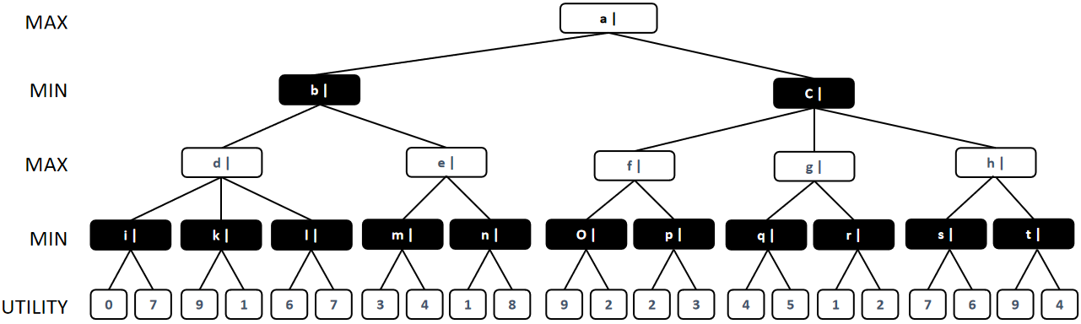

Evaluate MinMax values for all nodes (you can paste in an edited version of this tree below) **[10 pts]**:

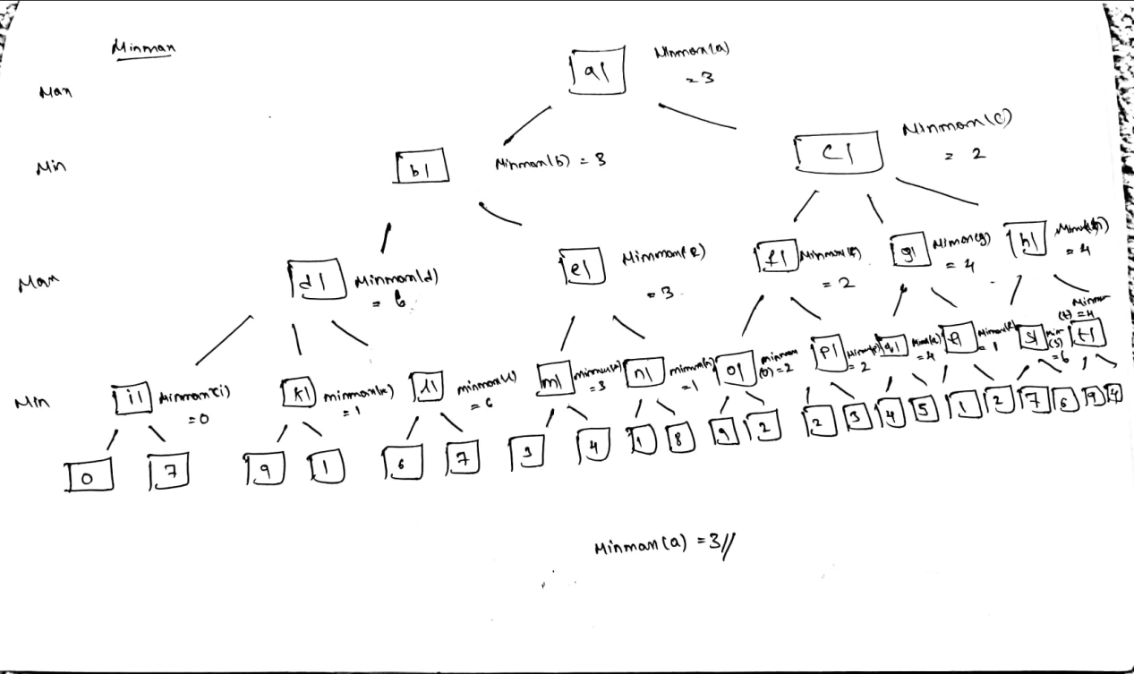

Now, apply **alpha-beta () pruning** to prune some of the tree branches. Show (you can paste in an edited version of this tree below) which sections of the tree will be pruned and**justify your answer [10 pts]**:

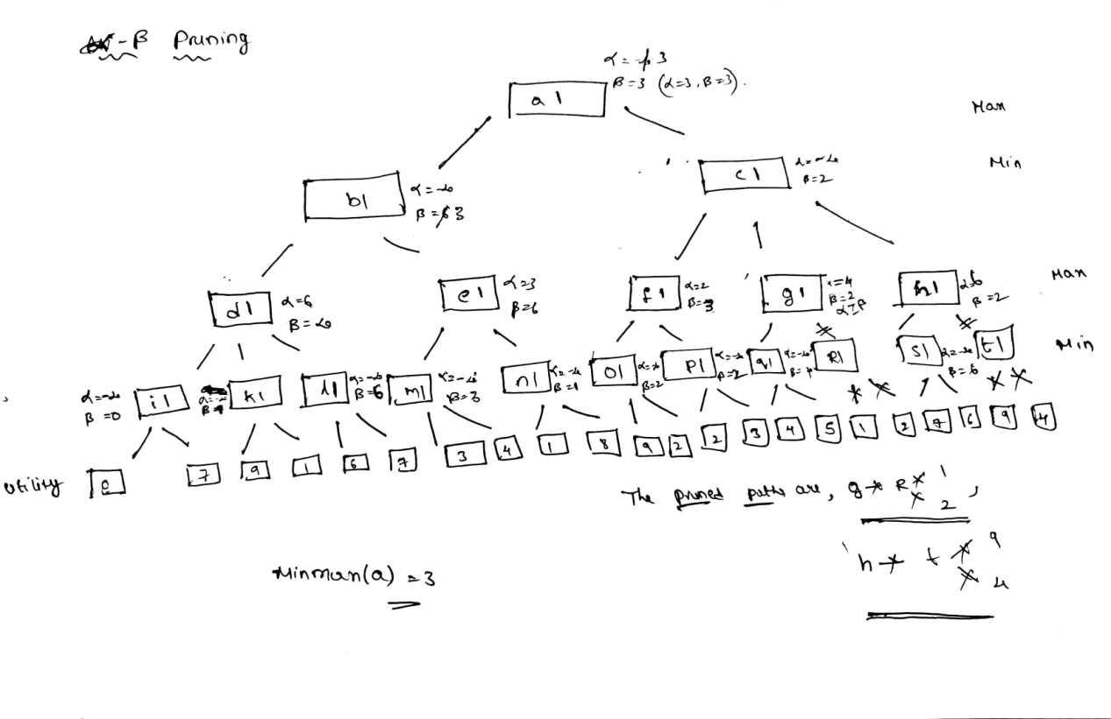

**Problem 2 [5 pts]:**

Use **truth tables** to show that the following sentences are **tautologies [5 pts]**:

1. ¬(p ∧ q) ⇔¬p ∨¬q **[5 pts]**

Place your truth table here.

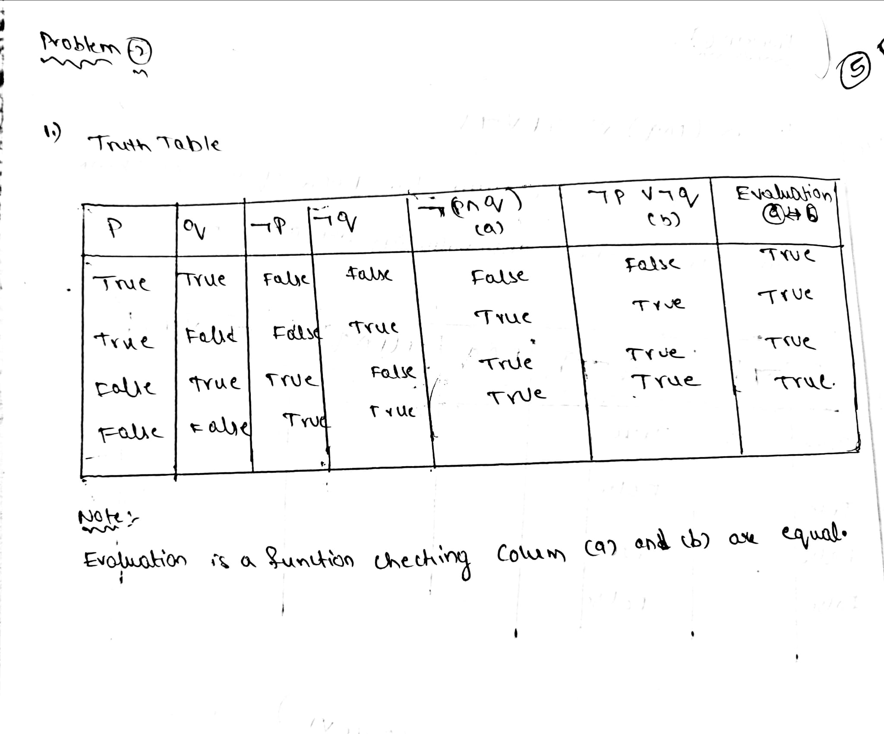

**Problem 3 [5 pts]:**

Use **deduction** to show (**prove**) that the following sentences are **tautologies**:

1. (¬b∨c)∧(a ∨ b∨ T) ⇒(a∨c ∨T) **[5 pts]**

|  |  |  |
| --- | --- | --- |
| **Your proof:** | | |
| **Step** | **Resulting sentence** | **Applied law / rule** |
| 1 | (¬b∨c) ∧(a∨b∨T) ⇒(a∨c∨T) | Negation law |
| 2 | (¬b∨c) ∧(a∨b) ⇒(a∨c) | Implication law |
| 3 | ¬ ((¬b∨c) ∧(a∨b)) ∨ (a∨c) | Distributive law |
| 5 | ¬ (¬b∨c) ∨(¬(a∨b)) ∨ (a∨c) | De Morgan’s law |
| 6 | (b∧¬c) ∨(¬b∧¬a) ∨ (a∨c) | Distributive law |
| 7 | ((b∧¬c) ∨(¬b)) ∧((b∧¬c) ∨(¬a)) ∨ (a∨c) | Distributive law |
| 8 | ((b∨¬b) ∧(¬c∨¬b)) ∨ ((b∨¬a) ∧ (¬c ∨¬a)) ∨ (a∨c) | Distributive law |
| 9 | ((b∨¬b) ∧(¬c∨¬b)) ∨ (((b∨¬a) ∧(a∨c)) ∨((¬c ∨¬a) ∨ (a∨c))) | Distributive law |
| 10 | ((b∨¬b) ∧(¬c∨¬b)) ∨ ((b∨¬a) ∧(a∨c)) | Distributive law |
| 11 | ((b∨¬b) ∧(¬c∨¬b)) ∨ ((b∨¬a) ∧(a∨c) ∨ T) | Distributive law |
| 12 | ((b∨¬b) ∧¬c) ∨((b∨¬b) ∨¬b)) ∨ ((b∨¬a) ∧ a) ∨  ((b∨¬a) ∧ c)) | Distributive law |
| 13 | ((b∨¬b) ∧¬c) ∨ T ∨ ((b∨¬a) ∧ a) ∨  ((b∨¬a) ∧ c)) | Domination law |
| 14 | T |  |
| Add more rows if necessary | Symbols (copy/paste): T⊥∨∧≡⇔¬⇒∴ | | |

**Problem 4 [10 pts]:**

Convert the following sentences into **conjunctive normal form** (**CNF**):

1. (p ∧ (p ⇒ q))⇒ q **[10 pts]**

|  |  |  |
| --- | --- | --- |
| **Your conversion steps:** | | |
| **Step** | **Resulting sentence** | **Applied law / rule** |
| 1 | (p ∧ (p ⇒ q))⇒ q | Implication law |
| 2 | ¬ (p ∧ (p ⇒ q)) ∨ q | Implication law |
| 3 | ¬ (p ∧ (¬p∨q)) ∨ q | Distributive law |
| 4 | ¬ ((p ∧ ¬p) ∨ (p∨q)) ∨ q | Negation law |
| 5 | ¬((F∨ (p∨q)) ∨ q | Identity law |
| 6 | ¬ (p∨q) ∨ q | Demorgan’s law |
| 7 | (¬p∧q) ∨ q | Distributive law |
| 8 | (¬p∨q) ∧(q∨q) | Identity law |
| 9 | (¬p∨q) ∧q |  |
| Add more rows if necessary | Symbols (copy/paste): T⊥∨∧≡⇔¬⇒∴ | | |

**Problem 5 [20 pts]:**

Use **proof by resolution** to show that this claim (sentence) below is true (a tautology):

➢m ➢ n  n ➢ o  o ➢ m

